French toast

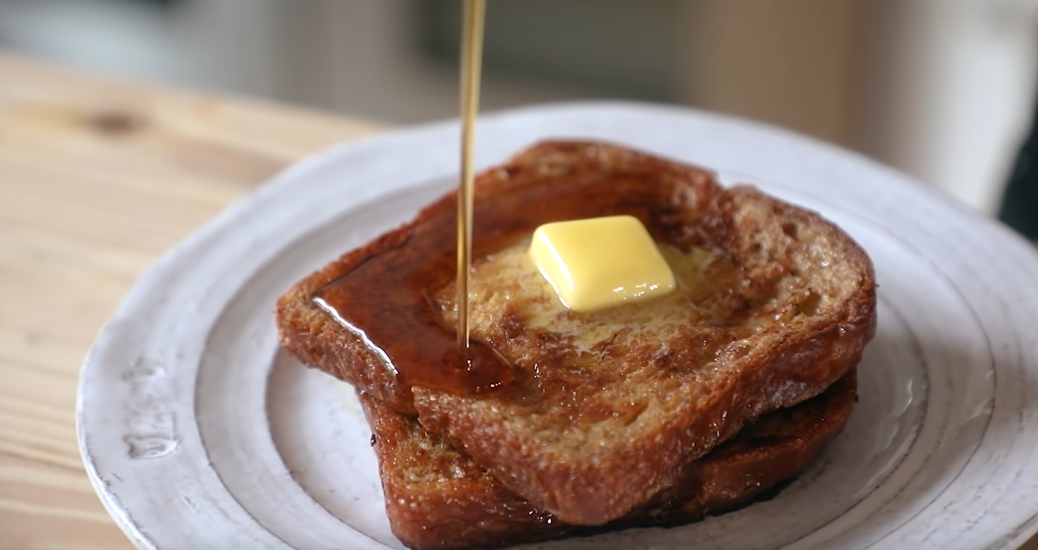

Ingredients you'll need:

Eggs

ground cinnamon

fine sea salt

light brown sugar

Pinch Fresh grated nutmeg

heavy whipping cream

whole milk

bread (preferably brioche or hallah)

Instructions:

To a bowl add 3 eggs and 2 yolks and combine with a few pinches of cinnamon and salt each. Then add a handful of light brown sugar along with a pinch of nutmeg. Mix to combine, then mix in an equal part of whole milk and half a part of whipping cream. Mix to combine again and transfer into a shallow dish for dunking the bread. Slice thick pieces of bread and let them soak the mixture. Melt butter in a pan and cook the toast until done.